# **Program to implement Gauss Jacobi Method**

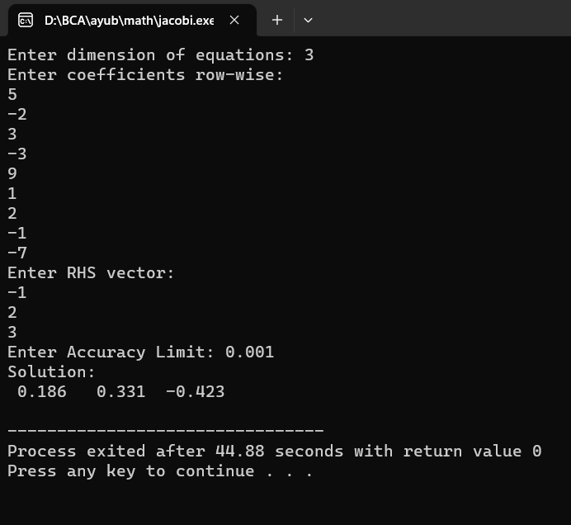a)

5x1-2x2+3x3 = -1

-3x1+9x2+x3=2

2x1-x2-7x3=3

b)

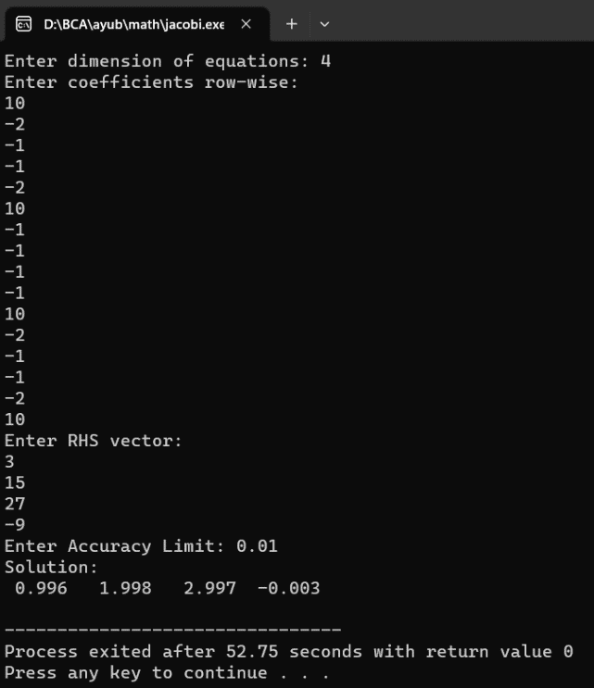10x1-2x2-x3-x4=3

-2x1+10x2-x­3-x4=15

-x1-x2+10x3-2x4=27

-x1-x2-2x3+10x4=-9